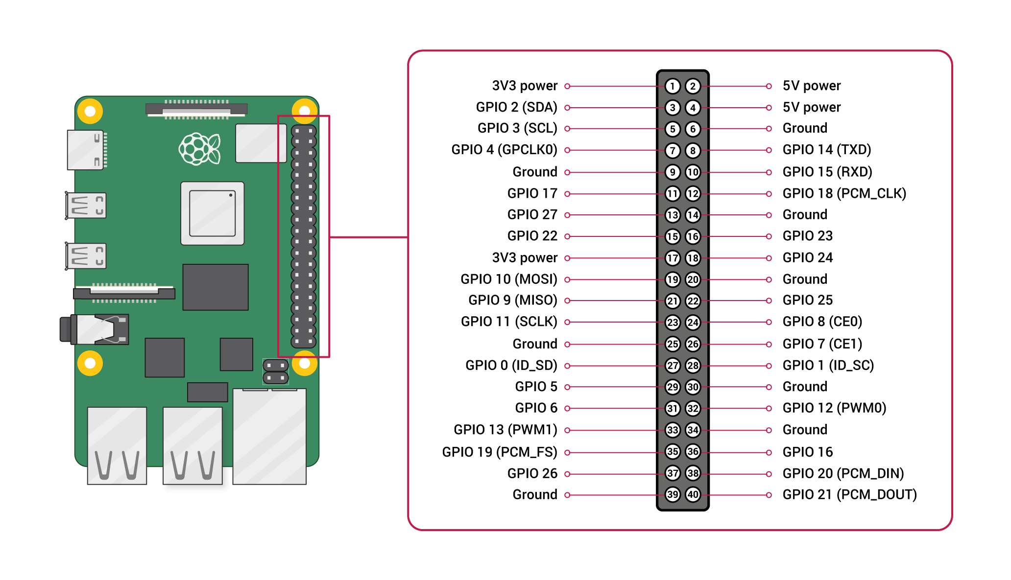

### PIR Sensor

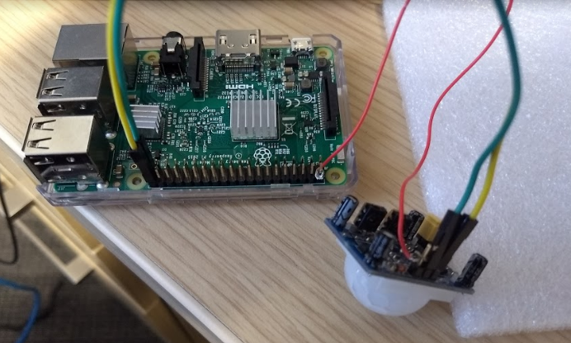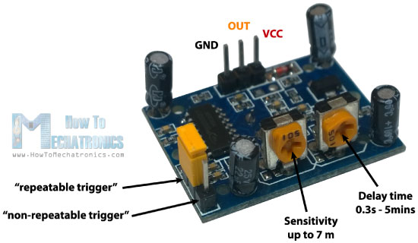

1. GND on PIR → PIN 39 on Raspberry Pi (Ground)
2. OUT on PIR → PIN 40 on Raspberry Pi (GPIO 21)
3. VCC on PIR → PIN 2 on Raspberry Pi (5V Power)

### IR Raspberry Pi-Camera

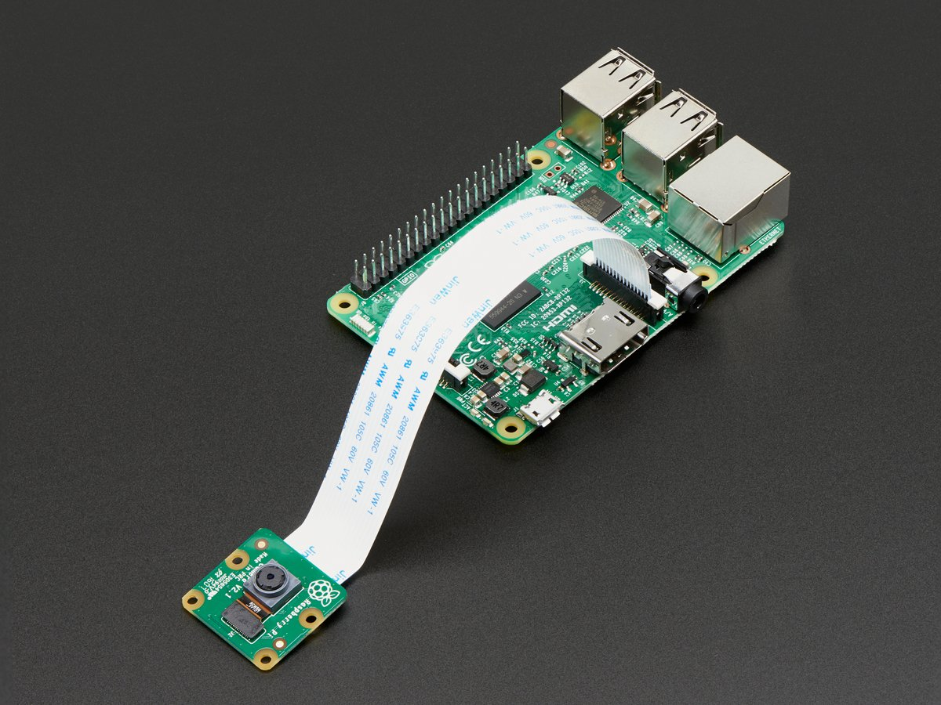

### Temperature-Humidity Sensor

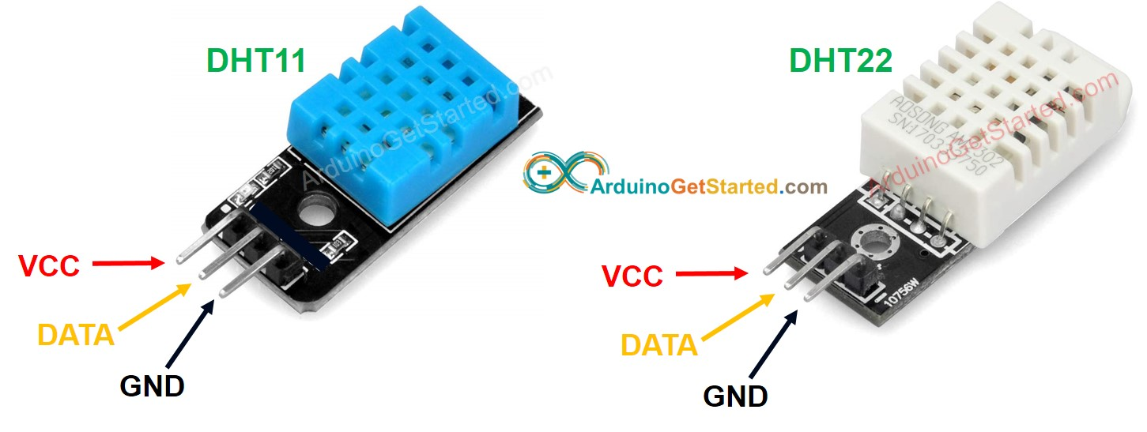

1. GND on DHT22 → PIN 14 on Raspberry Pi (Ground)
2. DATA on DHT22 → PIN 16 on Raspberry Pi (GPIO 23)
3. VCC on DHT22 → PIN 4 on Raspberry Pi (5V Power)

### Light Sensor

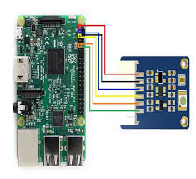

1. Red Wire on TCS34725 → PIN 1 on Raspberry Pi (3V3 Power)
2. Black Wire on TCS34725 → PIN 6 on Raspberry Pi (Ground)
3. Blue Wire on TCS34725 → PIN 3 on Raspberry Pi (GPIO 2 SDA)
4. Yellow Wire on TCS34725 → PIN 5 on Raspberry Pi (GPIO 3 SCL)
5. Orange Wire on TCS34725 → PIN 9 on Raspberry Pi (Ground)
6. Green Wire on TCS34725 → PIN 20 on Raspberry Pi (Ground)

Resource: <https://www.waveshare.com/w/upload/b/bb/TCS34725_Color_Sensor_user_manual_en.p>

